## **Lab 15: Android Media Player**

# **Introduction**

To utilise built-in media player services like playing audio, video, etc., Android offers the MediaPlayer class. We must invoke this class static method create() in order to use MediaPlayer. A MediaPlayer class instance is returned by this function. The grammar of it is as follows:

**Let’s get Started:**

This example shows how to create a MediaPlayer class to create a straightforward Audio Player in an Android Kotlin application.

**Step 1:** open **activity_main.xml** file from **\res\layout** folder path and write the code like as shown below.

**activity_main.xml**

*<?*xml version="1.0" encoding="utf-8"*?>*<RelativeLayout xmlns:android="http://schemas.android.com/apk/res/android"  
 xmlns:app="http://schemas.android.com/apk/res-auto"  
 xmlns:tools="http://schemas.android.com/tools"  
 android:layout_width="match_parent"  
 android:layout_height="match_parent"  
 tools:context=".MainActivity">  
  
 *<!-- creating text view for displaying heading-->* <TextView  
 android:id="@+id/idTVHeading"  
 android:layout_width="match_parent"  
 android:layout_height="wrap_content"  
 android:layout_above="@id/idEdtMsg"  
 android:layout_marginStart="20dp"  
 android:layout_marginTop="20dp"  
 android:layout_marginEnd="20dp"  
 android:layout_marginBottom="20dp"  
 android:gravity="center"  
 android:text="Plural Sight Demo for Clip Board in Android"  
 android:textAlignment="center"  
 android:textAllCaps="false"  
 android:textColor="#D32F2F"  
 android:textSize="20sp"  
 android:textStyle="bold" />  
<EditText  
 android:id="@+id/idEdtMsg"  
 android:layout_width="match_parent"  
 android:layout_height="wrap_content"  
 android:layout_centerInParent="true"  
 android:layout_margin="20dp"  
 android:hint="Thpe your content here" />  
<Button  
 android:id="@+id/idBtnCopyClipBoard"  
 android:layout_width="match_parent"  
 android:layout_height="wrap_content"  
 android:layout_below="@id/idEdtMsg"  
 android:layout_marginStart="20dp"  
 android:layout_marginTop="20dp"  
 android:layout_marginEnd="20dp"  
 android:layout_marginBottom="20dp"  
 android:text="Click to Copy to Clip Board"  
 android:textAllCaps="false"  
 android:backgroundTint="@color/teal_200"  
 android:textColor="#D32F2F" />  
</RelativeLayout>

**Step 2:** Open main [activity](https://www.tutlane.com/tutorial/android/android-activity-lifecycle) file **MainActivity.kt** and write the code like as shown below.

**MainActivity.kt**

package com.example.demopluralsightclipboard  
  
import android.content.ClipData  
import android.content.ClipboardManager  
import android.os.Bundle  
import android.support.v7.app.AppCompatActivity  
import android.widget.*  
class MainActivity : AppCompatActivity() {  
 lateinit var copyClipBoardBtn: Button  
 lateinit var msgEdt: EditText  
 override fun onCreate(savedInstanceState: Bundle?) {  
 super.onCreate(savedInstanceState)  
 setContentView(R.layout.*activity_main*)  
 copyClipBoardBtn = findViewById(R.id.*idBtnCopyClipBoard*)  
 msgEdt = findViewById(R.id.*idEdtMsg*)  
 copyClipBoardBtn.setOnClickListener {  
 val clipboardManager = getSystemService(*CLIPBOARD_SERVICE*) as ClipboardManager  
 val message = msgEdt.*text*.toString()  
 val clipData = ClipData.newPlainText("text", message)  
 clipboardManager.setPrimaryClip(clipData)  
 Toast.makeText(*applicationContext*, "Text copied to clip board", Toast.*LENGTH_SHORT*)  
 .show()  
 }  
 }  
}

**Step 3: Check Output on Android Emulator and it should look like as given below.**

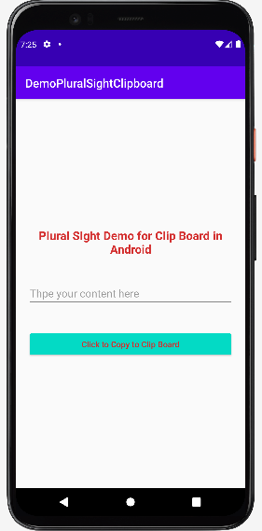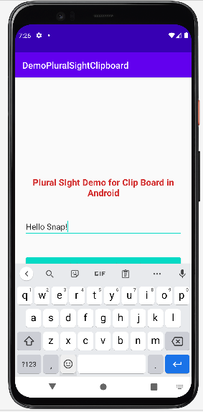 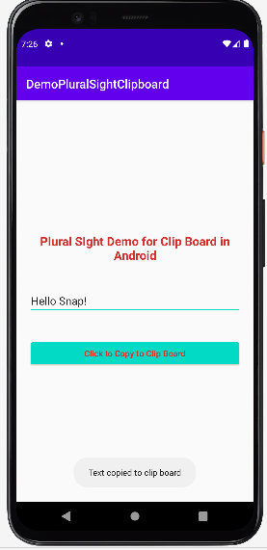

**Voila!!** We have successfully completed this lab.